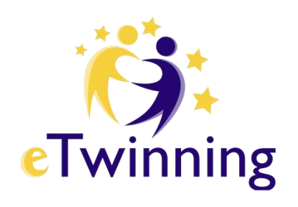

PARENT PERMISSION CERTIFICATE

THE STUDENT TO PARTICIPATE IN THE PROJECT
Protect the Environment, Protect the Future!

Name Surname |  | Father  Name
Class |  | Mother Name
No |  | Gender | G ( ) B ( )

I.C. “E. De Filippo” Sant’ Egidio del Monte Albino

The student of your school whose open identity is written above, whose parent I am / are present at, takes part in the activities held within the scope of eTwinning (European School Partnerships) projects, these activities are provided with pictures, videos, etc. I allow it to be published in social media and on the official website of our school, provided that it is recorded
in a way that supports education and training (with reliability).
07/01/2026

Parents Name Surname
Signatur

DESCRIPTIONS:
1- Every activity in eTwinning (European School Partnerships) projects is for educational purposes, to broaden the horizons of our students and to develop in different areas. It is legal and official at the same time.
- This permission document must be filled and signed by the mother, father/ legal guardian of the student who will participate in the above-mentioned event.
- The student who does not have a Permission Certificate participates in the activities, but his images are not published or his face is not visible.

